Version |  | Description |  | Created By | Date
1.0 |  | First version of the system |  | Amandeep Rikhi  Nancy Hada  Ritu Gaba  Shubham Gosain  Umang Gupta | 14-07-17
General Description
A use case is a methodology used in system analysis to identify, clarify, and organize system requirements. The use case is made up of a set of possible sequences of interactions between systems and users in a particular environment and related to a particular goal. It consists of a group of elements (for example, classes and interfaces) that can be used together in a way that will have an effect larger than the sum of the separate elements combined. The use case should contain all system activities that have significance to the users. A use case can be thought of as a collection of possible scenarios related to a particular goal, indeed, the use case and goal are sometimes considered to be synonymous.
A use case (or set of use cases) has these characteristics:
- Organizes functional requirements
- Models the goals of system/actor (user) interactions
- Records paths (called scenarios) from trigger events to goals
- Describes one main flow of events (also called a basic course of action), and possibly other ones, called exceptional flows of events (also called alternate courses of action)
- Is multi-level, so that one use case can use the functionality of another one.
Use cases can be employed during several stages of software development, such as planning system requirements, validating design, testing software, and creating an outline for online help and user manuals.

Actors <an entity that can interact with a system, invoking some behavior>
- Admin
- Users
Preconditions <the state(s) the system can be in before this use case starts>
- The System is functioning properly.
- The System should have access to the database.
- The Actor should have knowledge of working on the engine.
- The Actor must have a valid E-mail id.
- The Actor must have knowledge to create Surveys.
Use Case Diagram <a specific sequence of actions and interactions between actors and the system being discussed>
SURVEYKSHAN Use Case Diagram

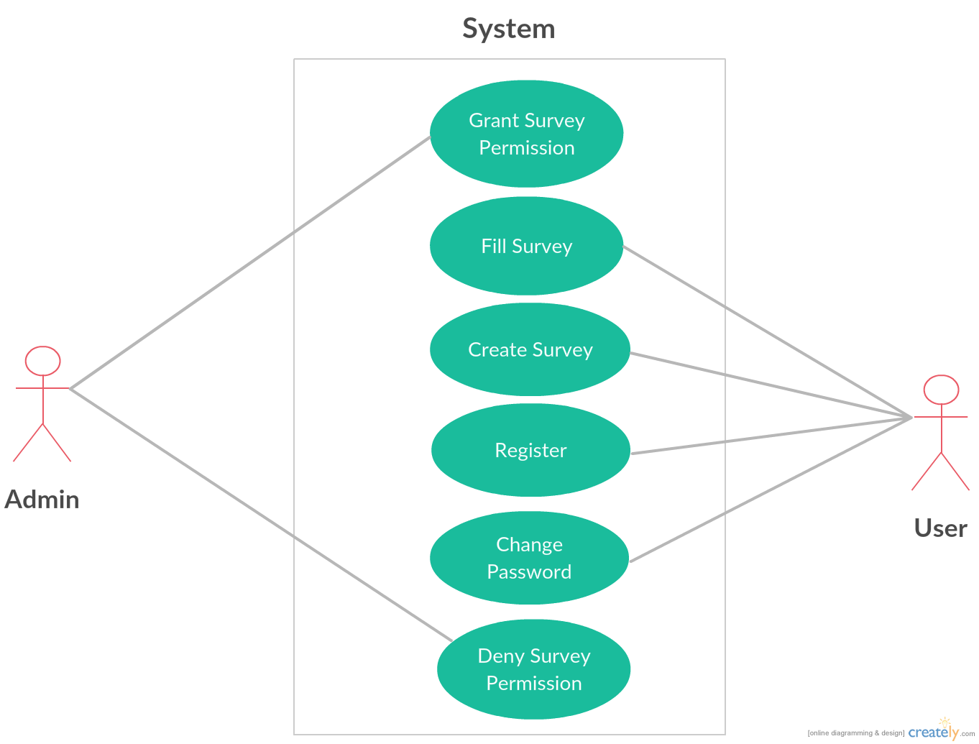

Basic flow of events: <a specific sequence of actions and interactions between actors and the system being discussed (happy path Or basic course of action)>
Line | System Actor Action |  | System Response
 | Admin Grant/Deny permission |  | Survey
 | User Registers |  | Registration Form
 | User Manages (Create, Fill Survey) |  | Survey
 | User Update (Change Password) |  | Forgot Password
 | Search-Search Results not found. Please modify your search. |  | Test Case
 | Login-Login successful or Login Failed: Re-enter your username and/or password. |  | Test Case

